**Milestone 3 Report**

1. **Baseline:**

|  |  |  |  |  |
| --- | --- | --- | --- | --- |
| Batch Size | Op Time 1 | Op Time 2 | Total Execution Time | Accuracy |
| 100 | *0.204844 ms* | *0.478707 ms* | *0m9.449s* | *0.86* |
| 1000 | *1.21288 ms* | *4.55513 ms* | *0m38.574s* | *0.886* |
| 10000 | *11.5176 ms* | *45.7344 ms* | *6m18.283s* | *0.8714* |

Note:

1. For Nsight profiling results, the baseline is selected as the second conv_forward_kernel.
2. OP and Total Execution Time are measured with -DCMAKE_CXX_FLAGS=-pg during compilation.

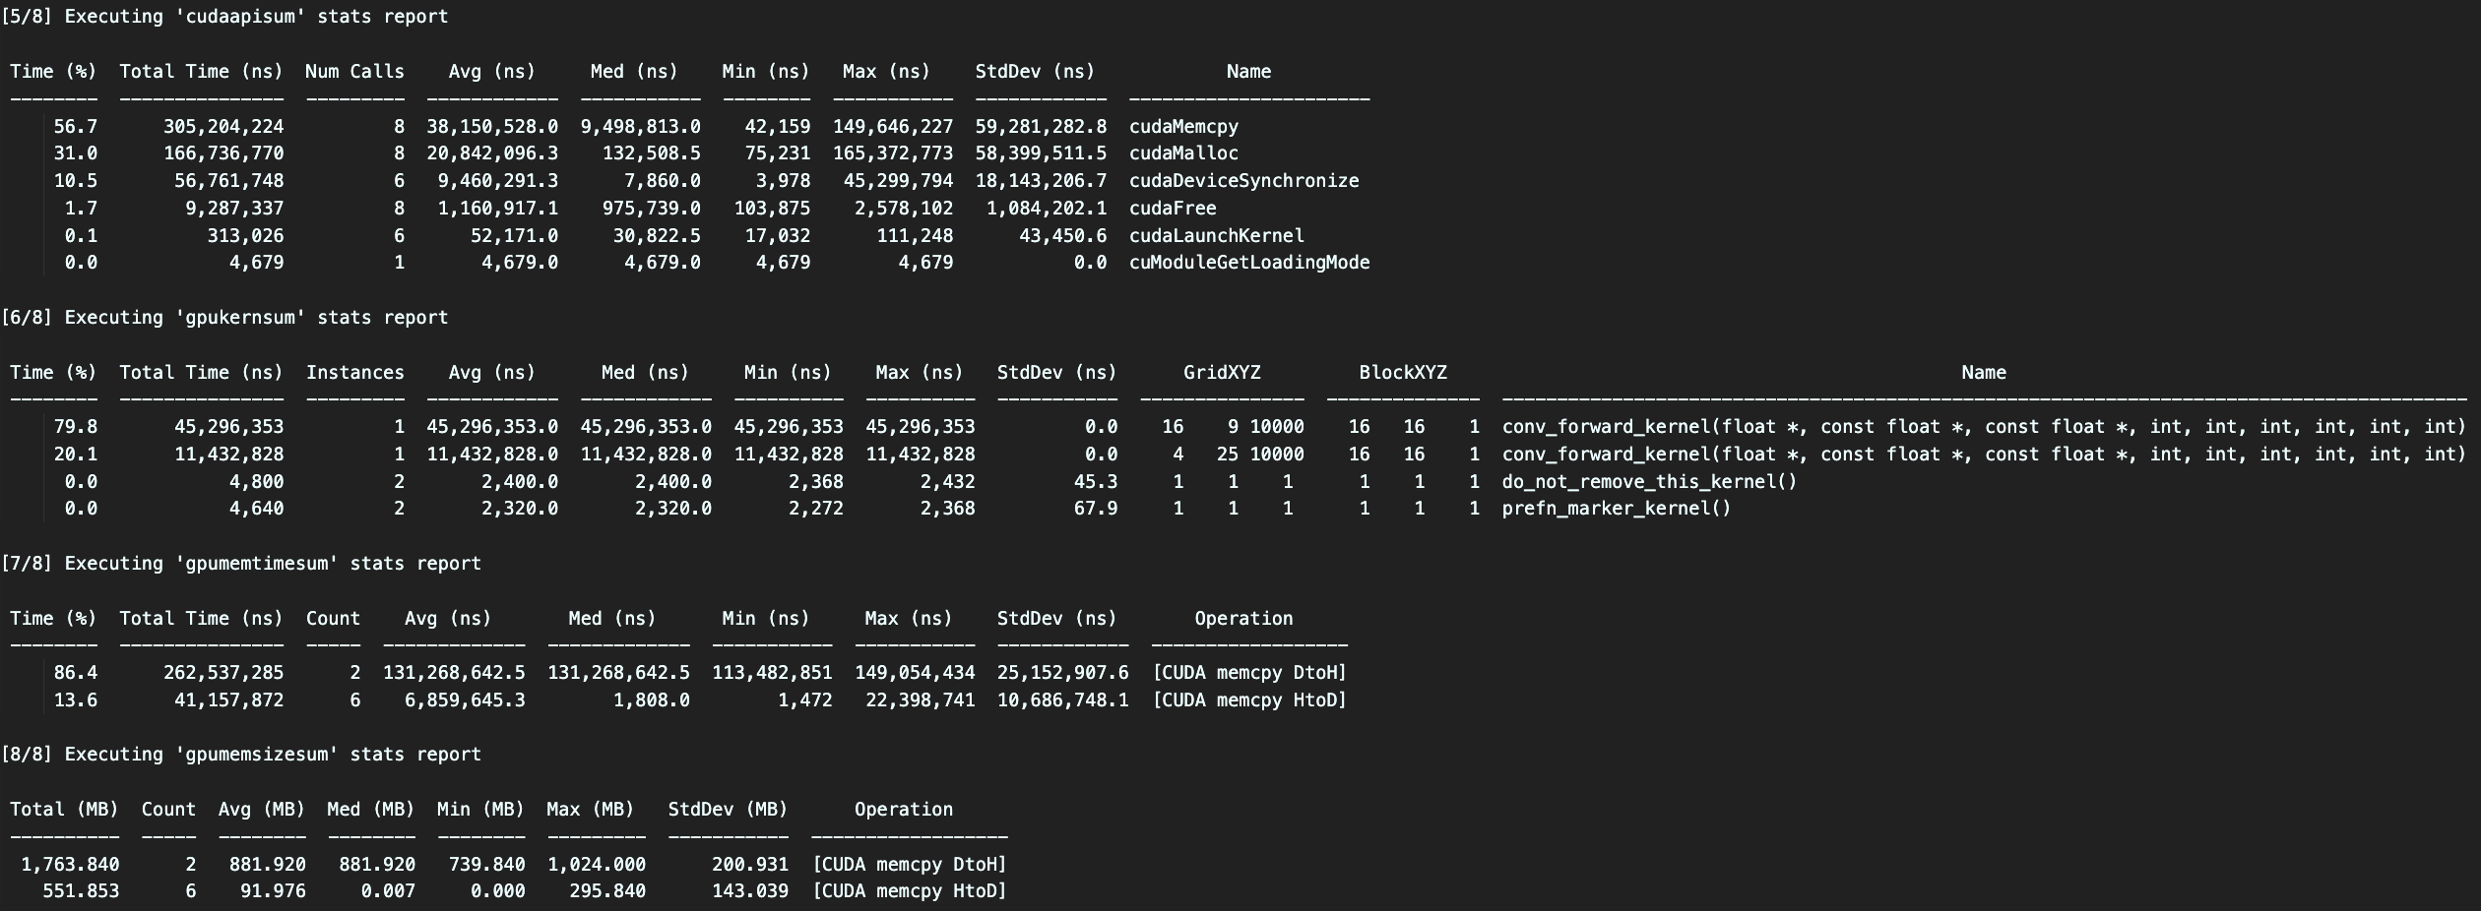



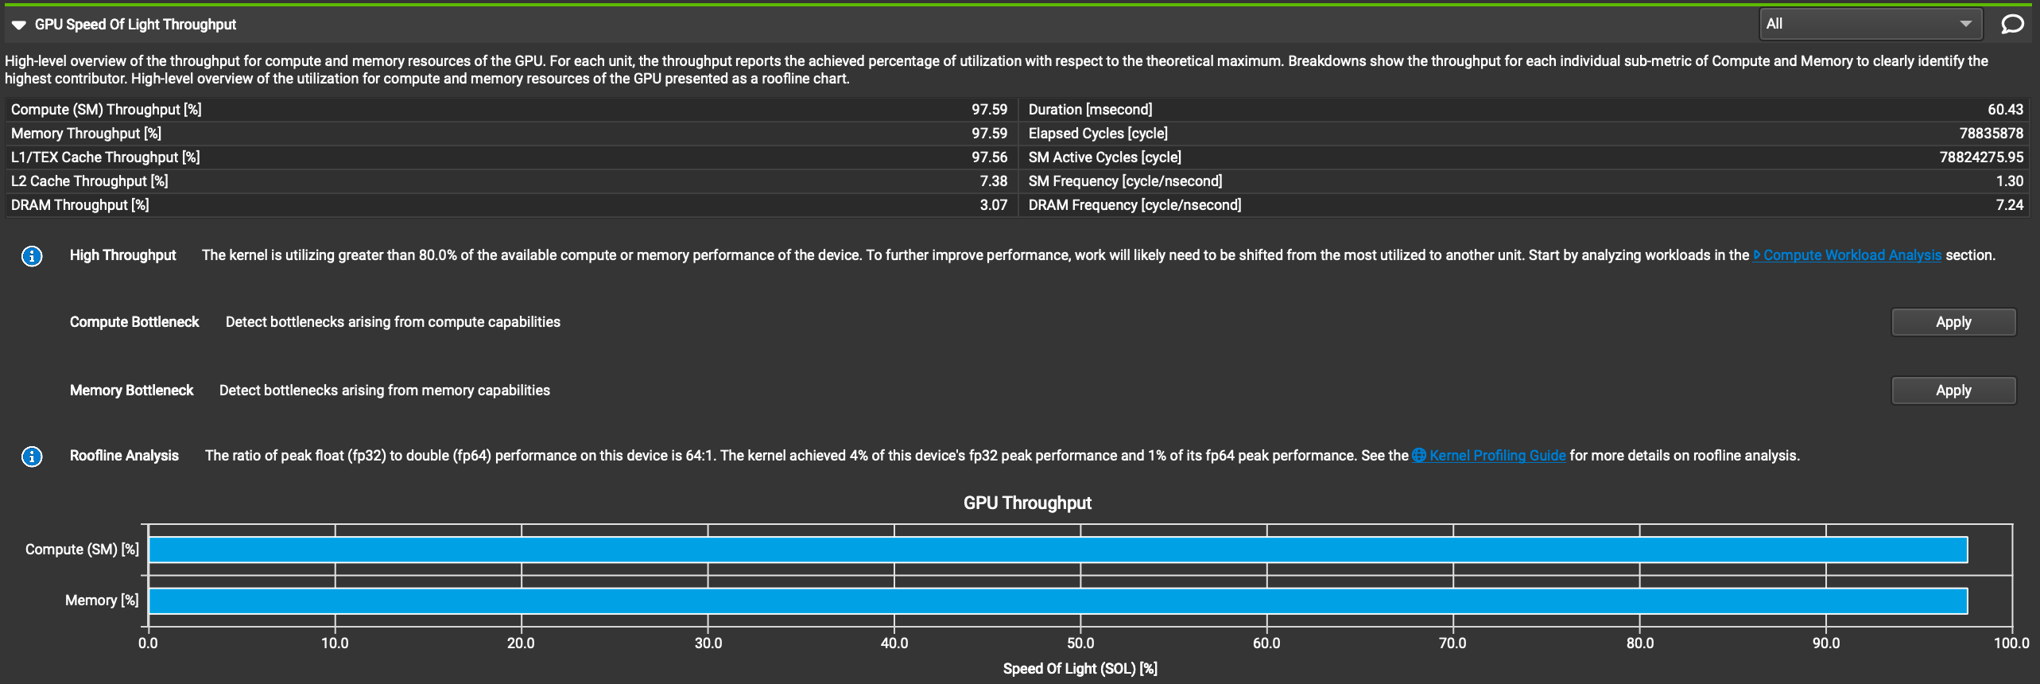

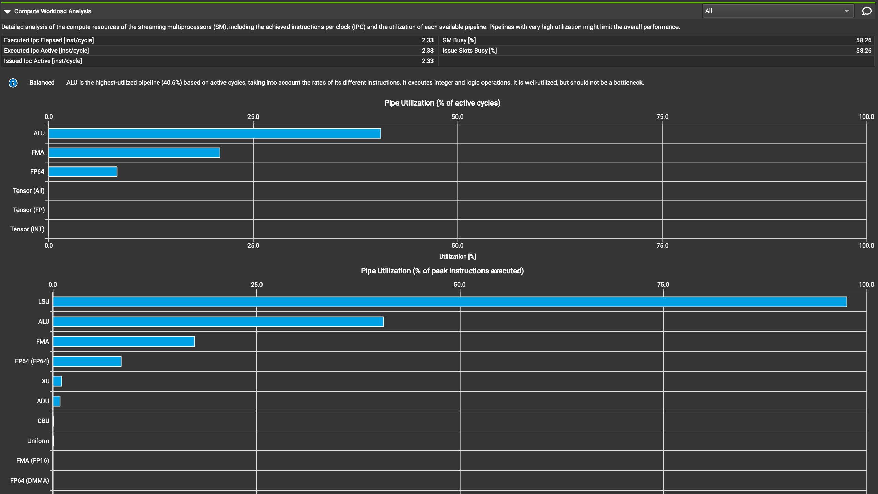



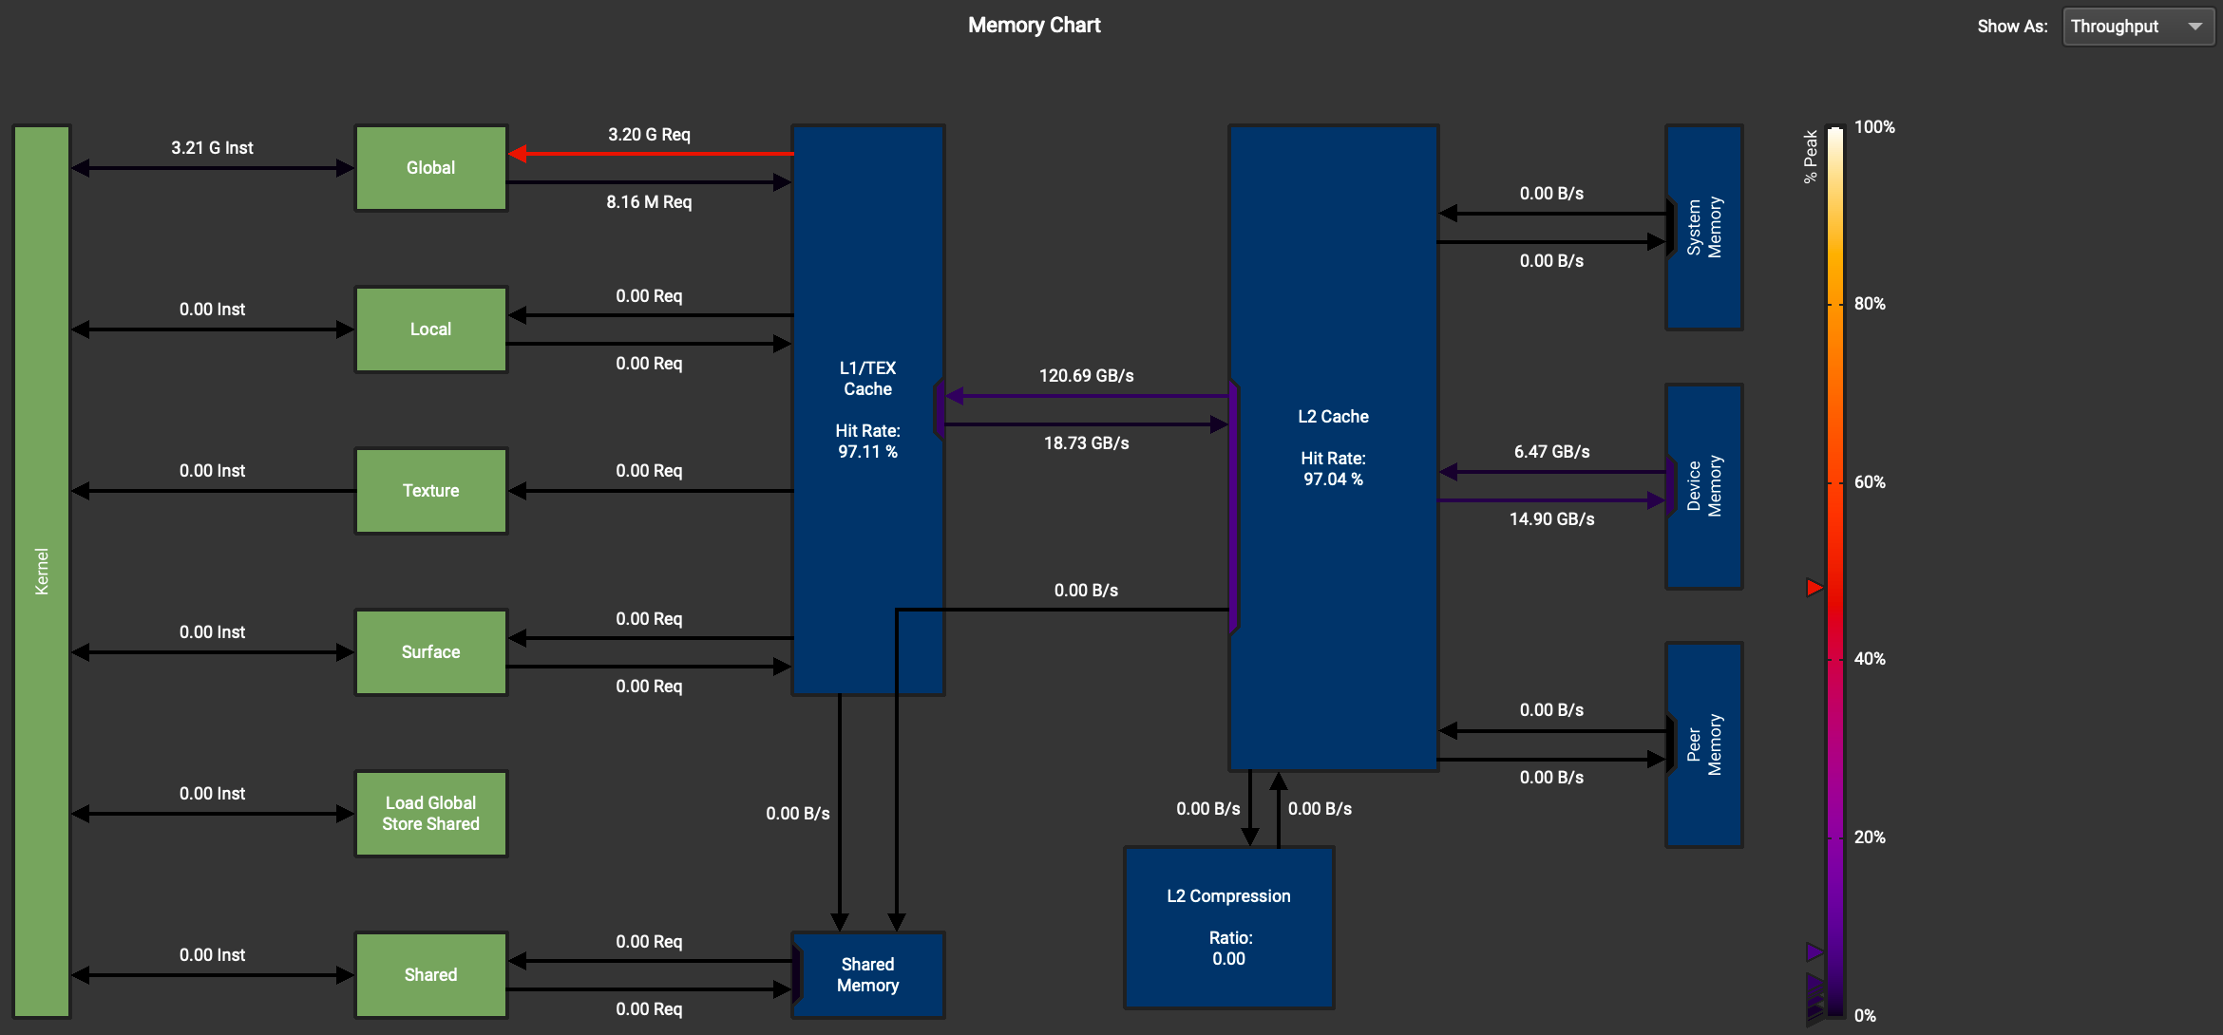

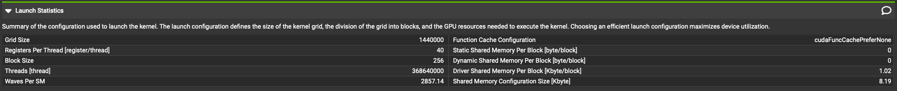



1. **Optimization Number 0: Using Streams to overlap computation with data transfer**
   1. How does this optimization work in theory? Expected behavior?

We can parallelize data transfer and computation so that computation doesn’t need to wait for data copies before it can proceed.

OP Time and total execution time should decrease; There should be multiple streams, and each stream should have a lower duration and less data transfer than the baseline.

* 1. How did you implement your code? Explain thoroughly and show code snippets.

To avoid changing headers of the host functions, my code is restructured so that stream creation (20 streams), memory copies, kernel invocations, and stream destructions are put in the conv_forward_gpu_prolog host function. Memory copies to and from the device are split into multiple streams and are asynchronous to the kernel invocation. Core host code:

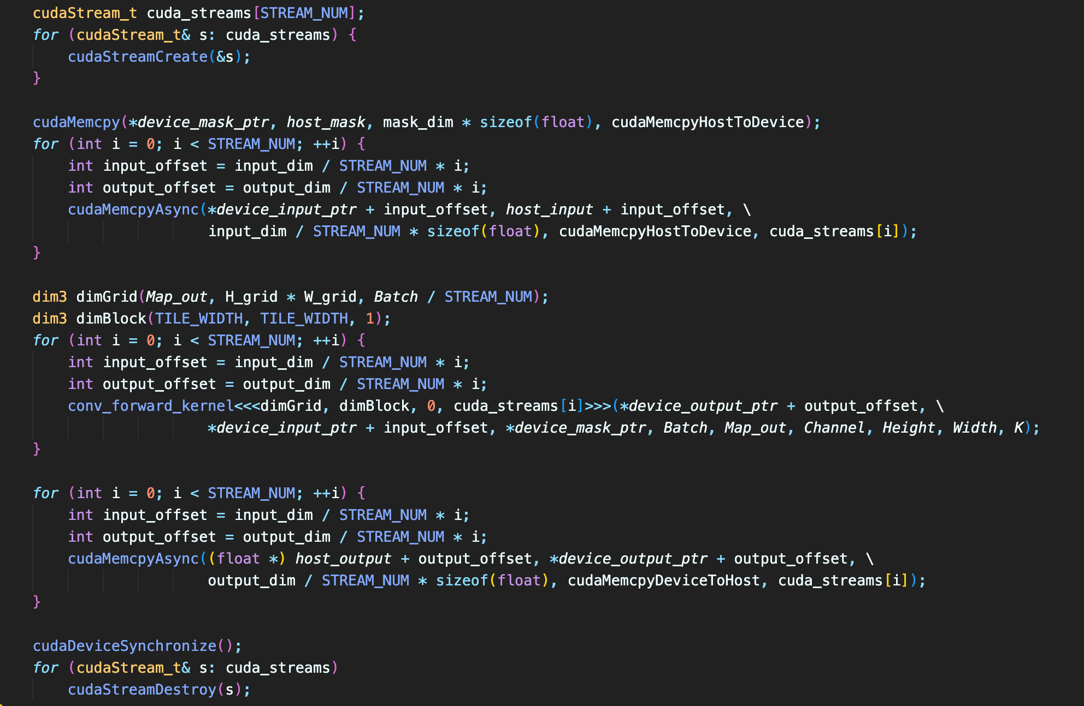

* 1. Did the performance match your expectation? Show your analysis results using profiling tools.

|  |  |  |  |  |
| --- | --- | --- | --- | --- |
| Batch Size | Op Time 1 | Op Time 2 | Total Execution Time | Accuracy |
| 100 | *0.001032 ms* | *0.000892 ms* | *0m3.987s* | *0.86* |
| 1000 | *0.001192 ms* | *0.000971 ms* | *0m37.907s* | *0.886* |
| 10000 | *0.000992 ms* | *0.008396 ms* | *6m5.290s* | *0.8714* |

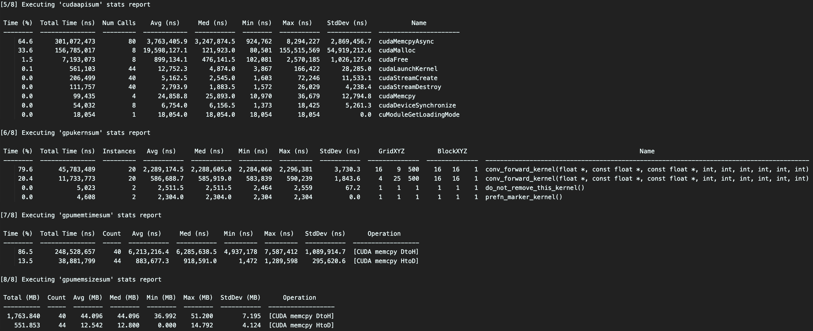

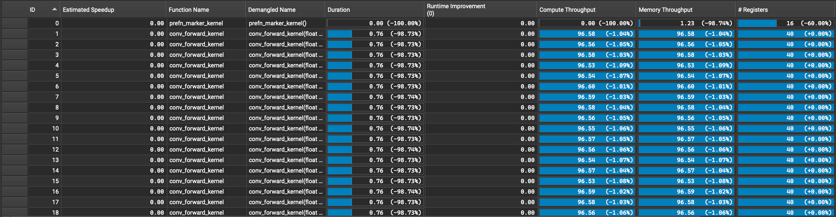

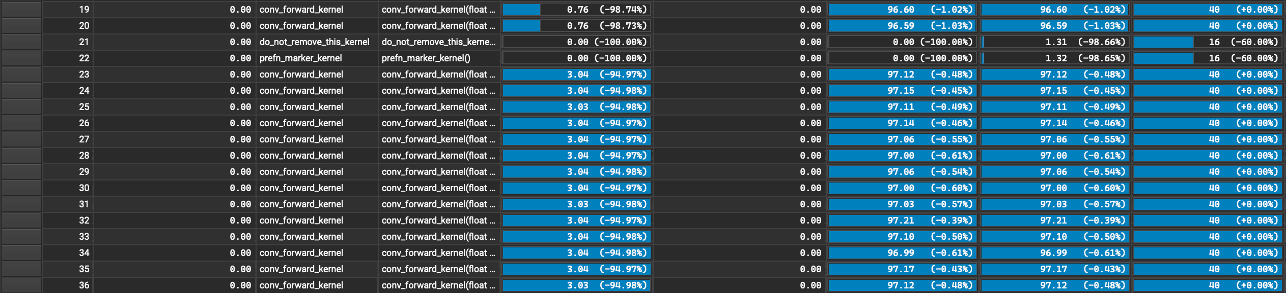



For one convolutional stream:

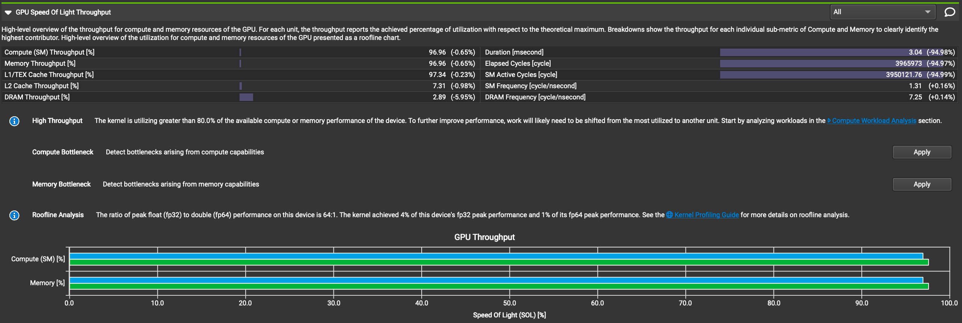



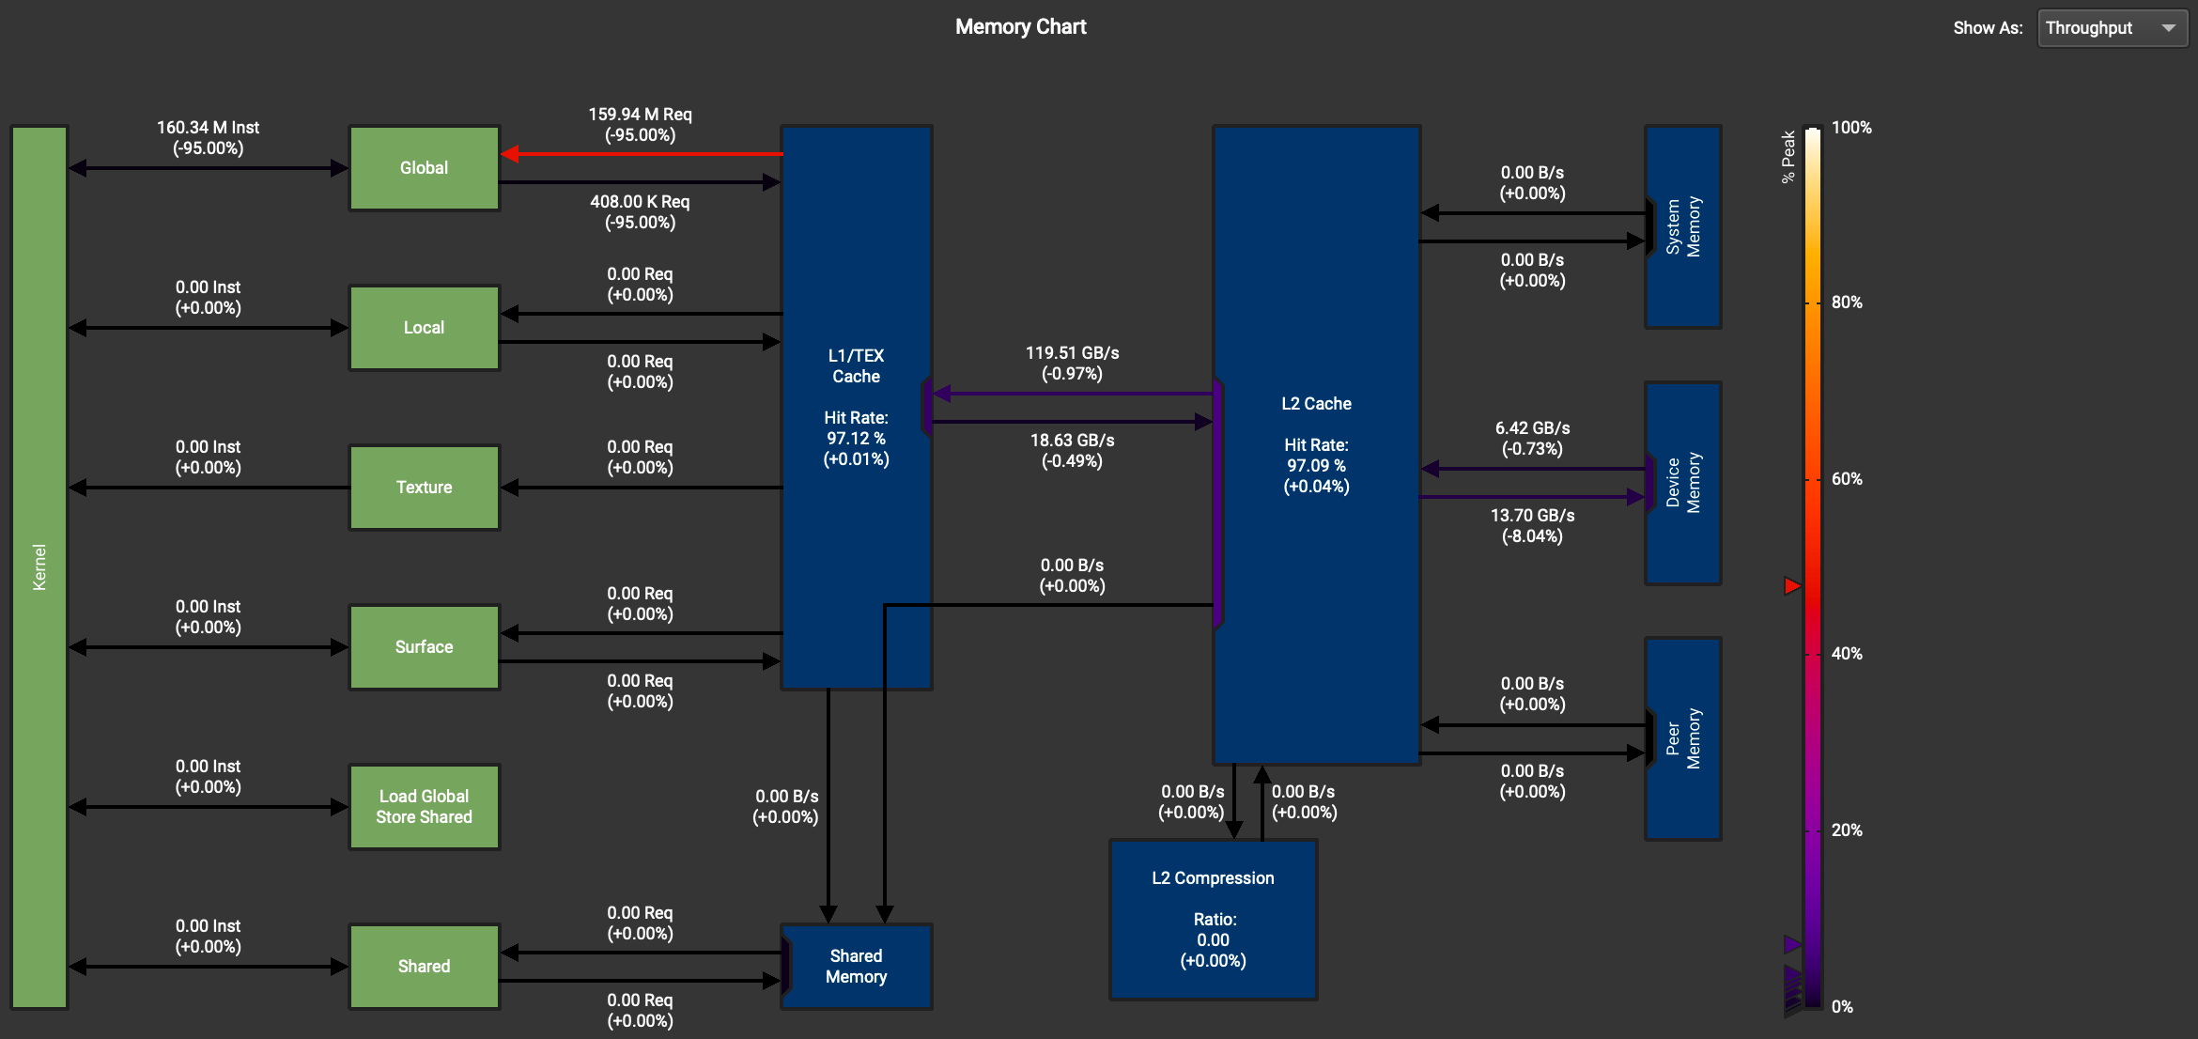

Yes. Duration for each stream is decreased by ~95%, which means each stream took about 1/20 of the duration of the baseline. As shown by the memory chart, data transfers between the kernel and global memory also decreased by 95%. The total execution time decreased as expected, OP Time decreased a lot since the conv_forward_gpu function in this optimization is almost empty.

* 1. Does this optimization synergize with any other optimizations? How and why?

Yes, this optimization should be able to synergize with any other optimization. The core methodology of this optimization is overlapping data transfer with computation, which is applicable to any other optimization.

* 1. List your references used while implementing this technique. (you must mention textbook pages at the minimum)

Hwu, W. M. W., Kirk, D. B., & Hajj, I. E. (2022). Programming Massively Parallel Processors: A Hands-on Approach, Fourth Edition, pages 462-470.

1. **Optimization Number 1: Tiled (shared memory) convolution**
   1. How does this optimization work in theory? Expected behavior?

This method can load data from global memory (~500 cycles) to the shared memory (~5 cycles) and then the kernel can reuse data stored in the shared memory. This method is also memory coalesced so the computation can be more efficient.

The global memory throughput should be lower, the shared memory should have significant throughput, and the total execution time should be decreased.

* 1. How did you implement your code? Explain thoroughly and show code snippets.

The size of the shared memory (mask + input) is first calculated on the host side and passed to the kernel as the third parameter of kernel invocation.

In the kernel, iterate through channels, and load data from global memory to shared memory if the address is within boundaries. Then, run __syncthreads() before and after the convolution computation. Finally, write back the accumulated result after all channels have been iterated. Core kernel code:

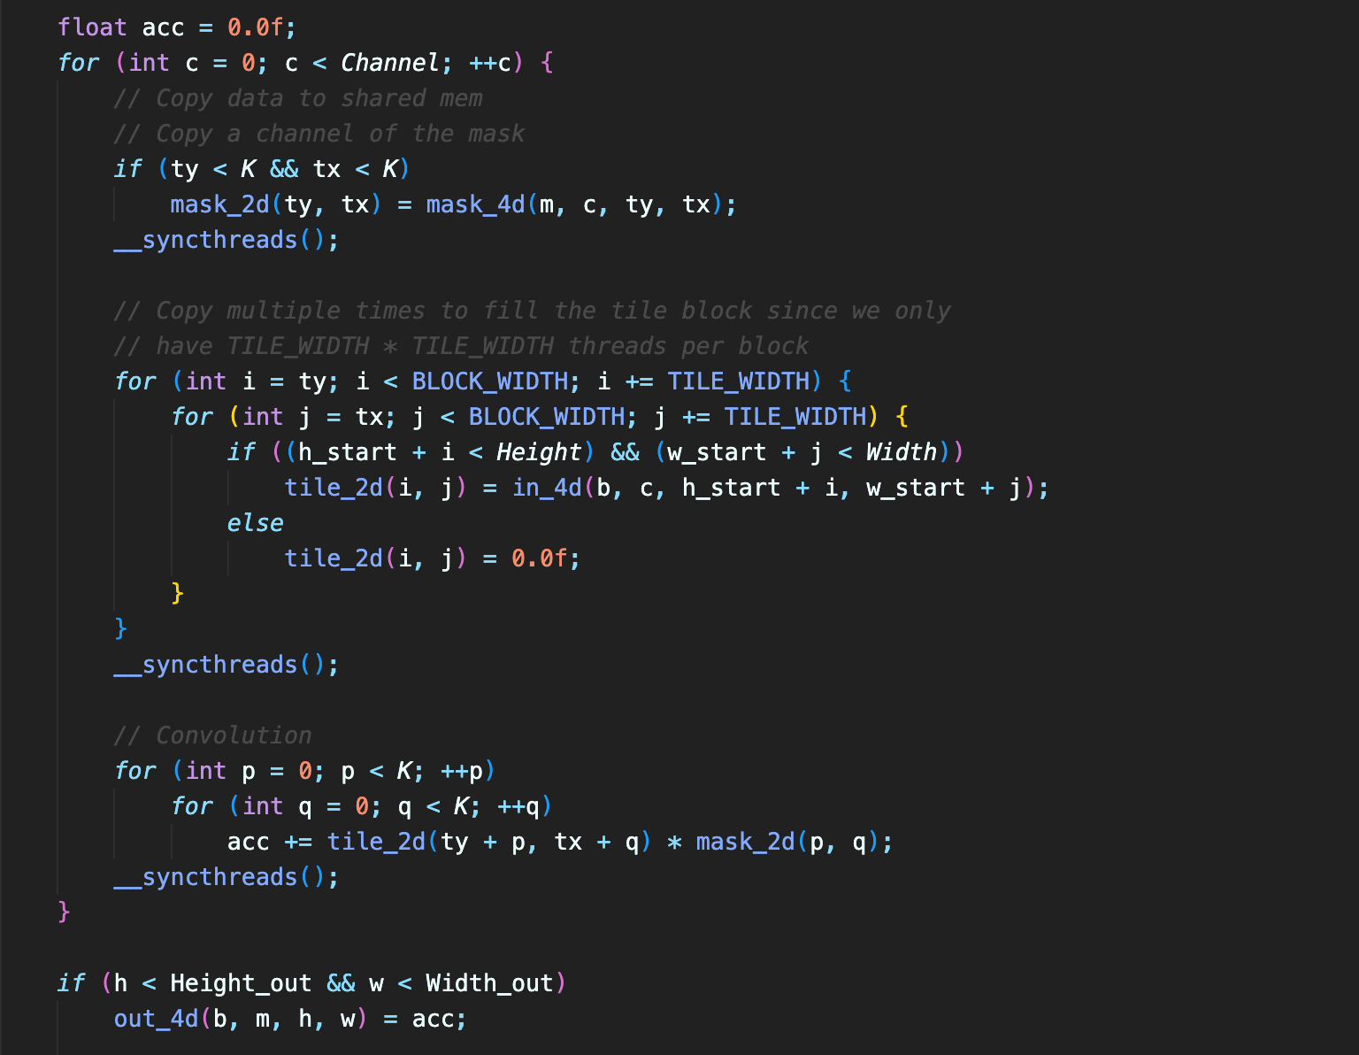

* 1. Did the performance match your expectation? Show your analysis results using profiling tools.

|  |  |  |  |  |
| --- | --- | --- | --- | --- |
| Batch Size | Op Time 1 | Op Time 2 | Total Execution Time | Accuracy |
| 100 | *0.237925 ms* | *0.749995 ms* | *0m5.681s* | *0.86* |
| 1000 | *1.37637 ms* | *7.26795 ms* | *0m36.327s* | *0.886* |
| 10000 | *12.9498 ms* | *72.3508 ms* | *6m1.667s* | *0.8714* |

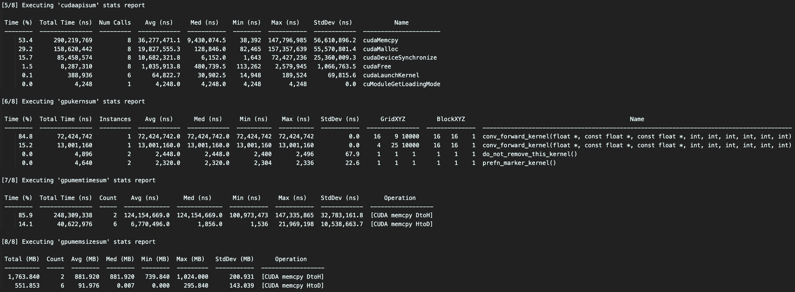



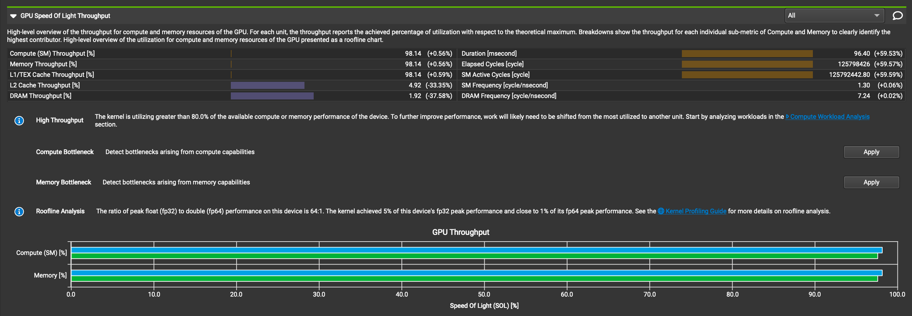

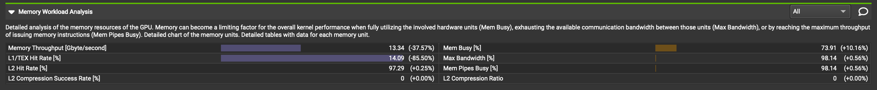

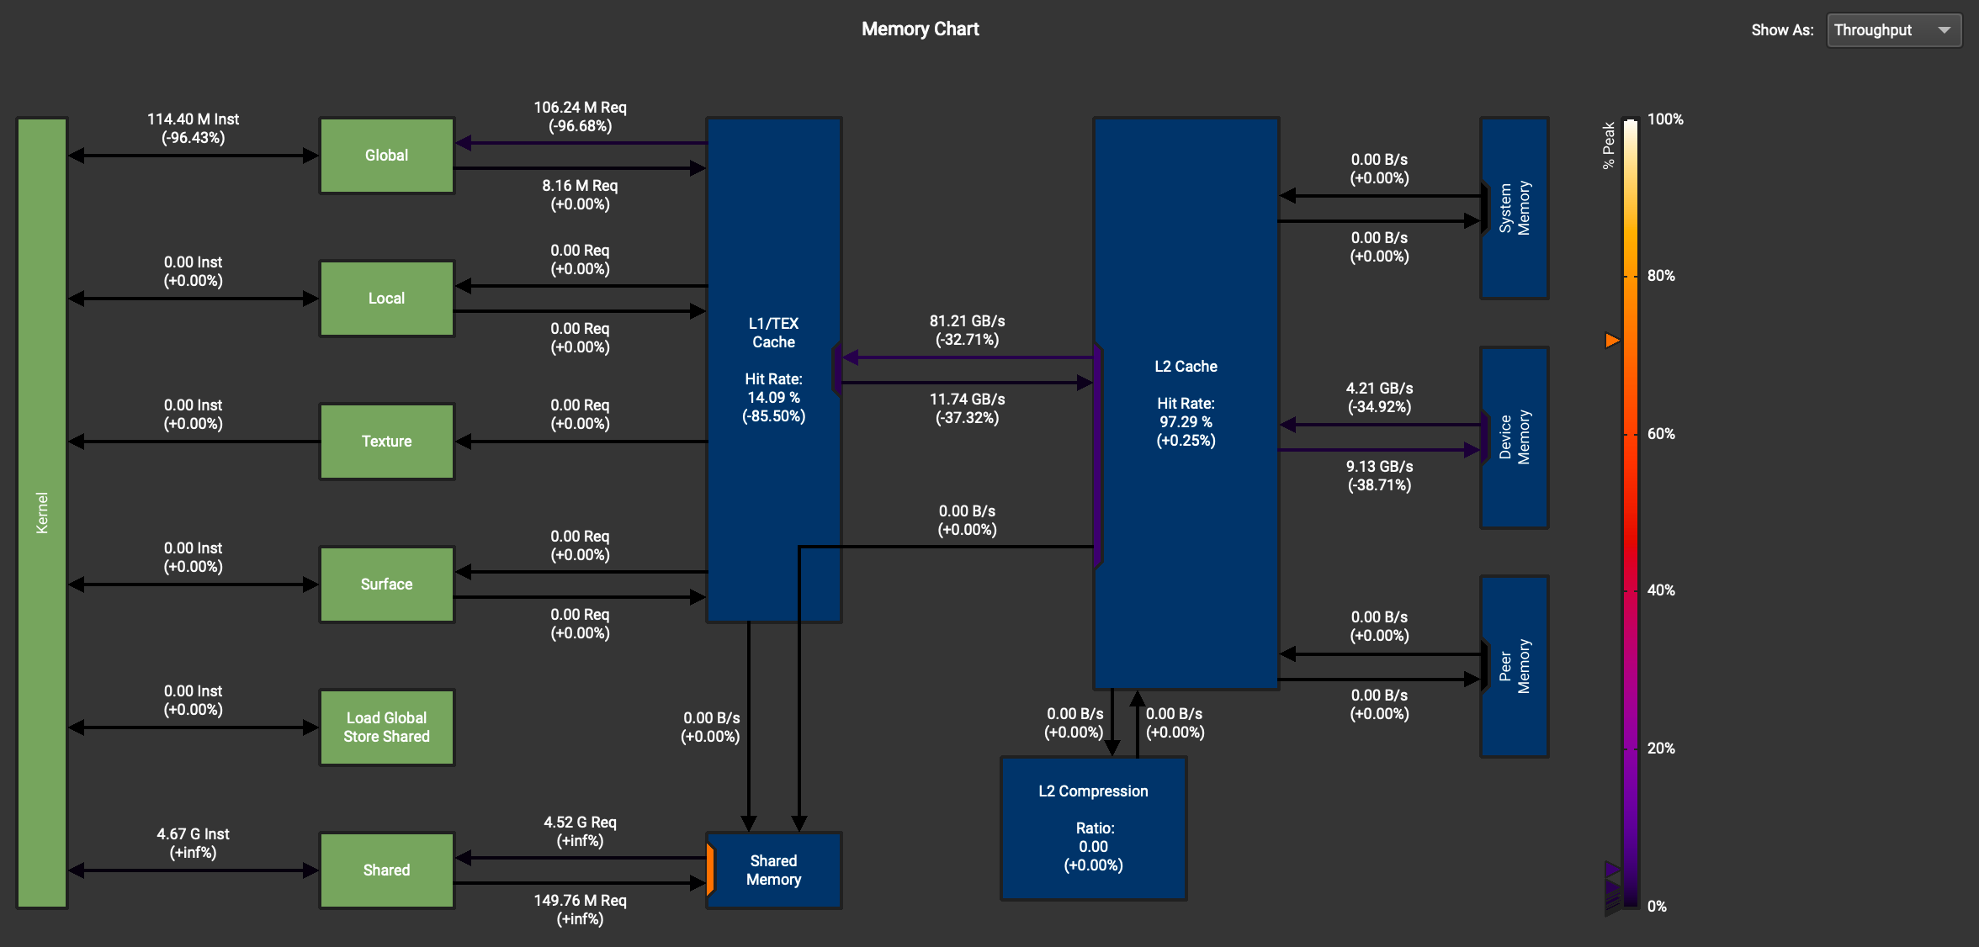

Yes. As shown by the table and the chart, throughput between kernel and global memory decreased by 96.43%, and throughput between kernel and shared memory became much larger than the global memory (4.67G compared to 114.4M). There’s also a significant decrease in the throughput between L2 Cache and device memory. Total execution time also decreased compared to the baseline. However, Nsight highlights duration as it increased for 59.53%.

* 1. Does this optimization synergize with any other optimizations? How and why?

Yes, it can synergize with optimizations like OP2 and OP4. For OP2, the matrix multiplication can be tiled with shared memory; For OP4, we can store the weight matrix in constant memory and use tiled convolution with shared memory like this optimization. OP2 and OP4 can both take advantage of tiling and shared memory without too many logic changes.

* 1. List your references used while implementing this technique. (you must mention textbook pages at the minimum)

Hwu, W. M. W., Kirk, D. B., & Hajj, I. E. (2022). Programming Massively Parallel Processors: A Hands-on Approach, Fourth Edition, pages 115-117, 163-170.

1. **Optimization Number 2: Input matrix unrolling & tiled matrix multiplication using shared memory**
   1. How does this optimization work in theory? Expected behavior?

The input can be unrolled to a matrix to multiply with the weight matrix, resulting in the exact output of an ordinary convolution. Matrix multiplication is highly optimized and can potentially improve performance.

The global memory throughput should be lower, the shared memory should have significant throughput. The total execution time should be decreased due to the optimized GEMM computation, but OP Time might increase because of the increased preparation workload on the host.

* 1. How did you implement your code? Explain thoroughly and show code snippets.

I implemented two kernels – one for unrolling the input matrix, and the other for tiled matrix multiplication with shared memory. For batch_size = 10000, experiments showed that data needed to be split into smaller batches. For each small batch, unroll the input to an allocated global memory on the first kernel, then run tiled matrix multiplication on the second kernel. Core host code:

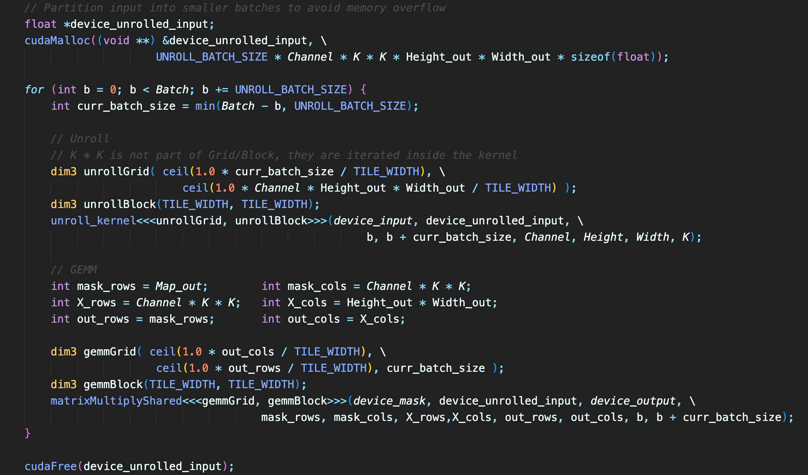

The unrolling kernel calculates the corresponding location of the data and load it to the unrolled global memory. Core unrolling kernel code:

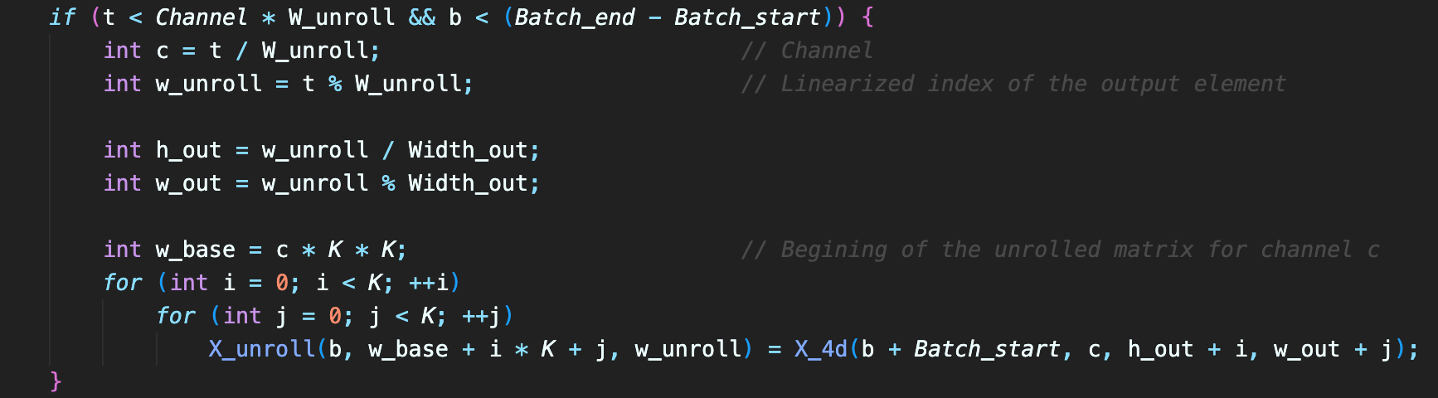

Matrix multiplication kernel is from lab 3. Core GEMM kernel code:

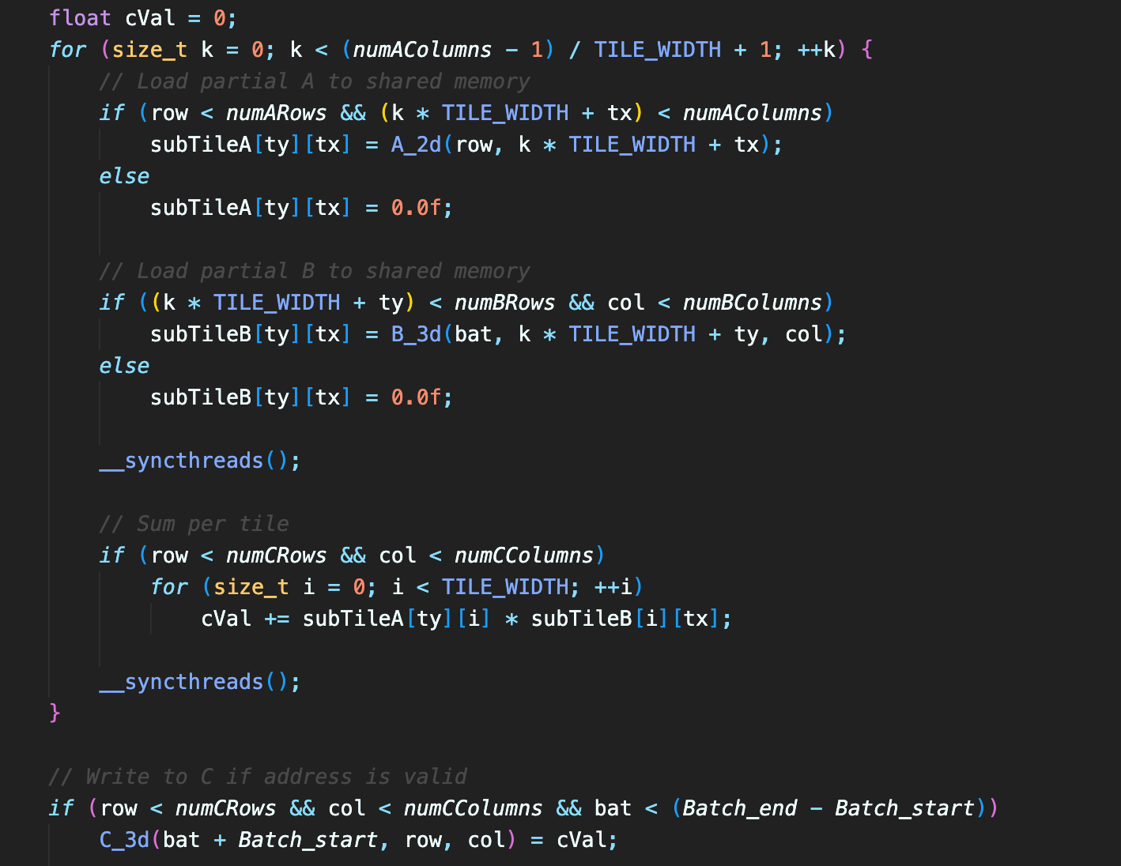

* 1. Did the performance match your expectation? Show your analysis results using profiling tools.

|  |  |  |  |  |
| --- | --- | --- | --- | --- |
| Batch Size | Op Time 1 | Op Time 2 | Total Execution Time | Accuracy |
| 100 | *4.79964 ms* | *3.58301 ms* | *0m4.122s* | *0.86* |
| 1000 | *35.7431 ms* | *27.8717 ms* | *0m37.555s* | *0.886* |
| 10000 | *419.741 ms* | *344.806 ms* | *6m10.334s* | *0.8714* |

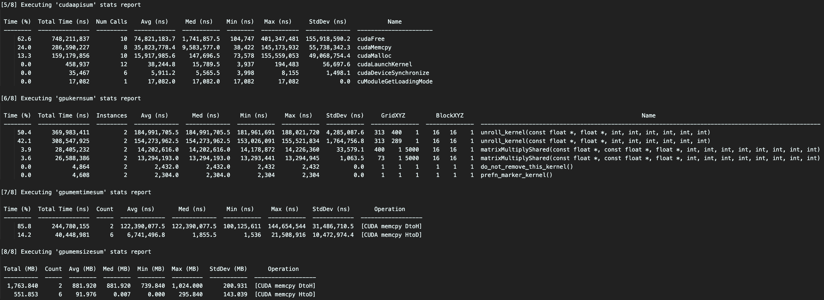

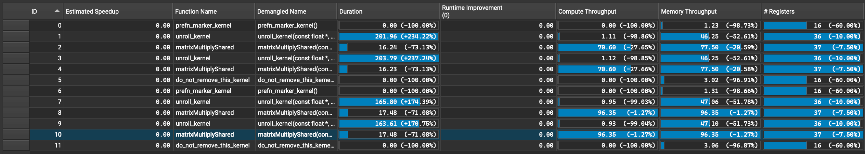

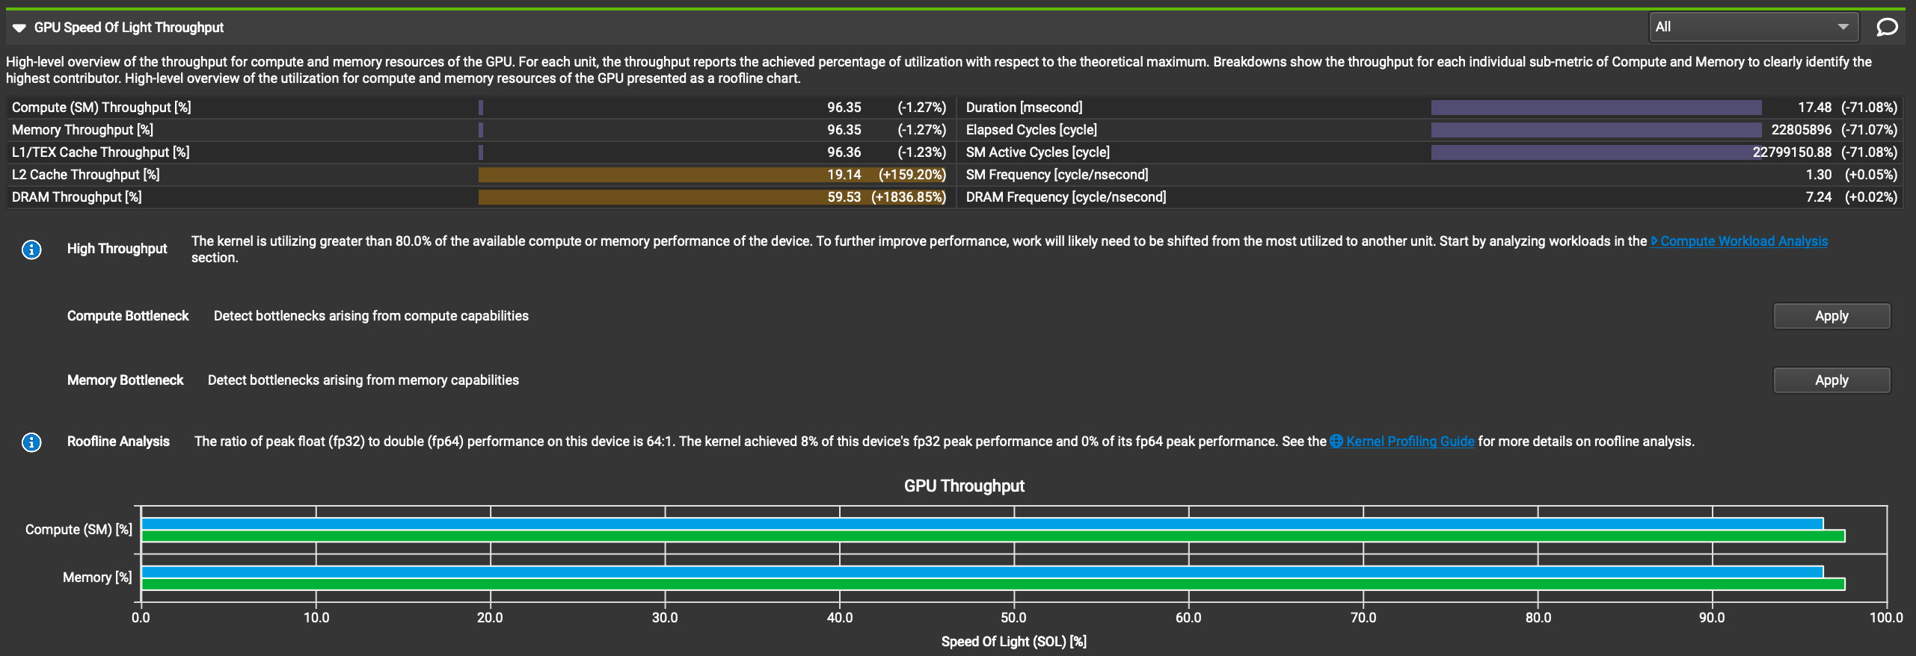

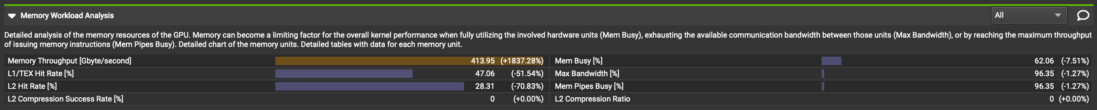

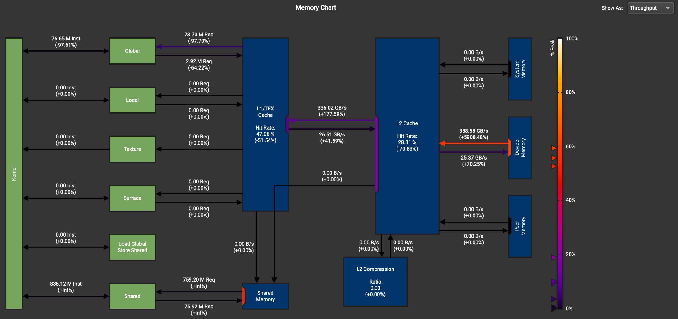

Not exactly. The memory workload analysis table showed a dramatic increase in memory throughput, despite the expected decrease in the throughput of global memory and an increase in throughput of shared memory. OP Time does increase since the host needs to allocate memory for the unrolled input and loop twice for the entire batch of data, and total execution time decreased due to improved GEMM performance.

* 1. Does this optimization synergize with any other optimizations? How and why?

Yes, it can synergize with optimizations like OP3 and OP6. For OP3, we can simply put two kernels together and reduce kernel invocations to improve performance; For OP6, we can try different tile widths, block sizes, etc. to find the optimal parameters. OP3 and OP6 can act as add-ons to OP2 to further improve performance.

* 1. List your references used while implementing this technique. (you must mention textbook pages at the minimum)

Hwu, W. M. W., Kirk, D. B., & Hajj, I. E. (2022). Programming Massively Parallel Processors: A Hands-on Approach, Fourth Edition, pages 107-112, 376-385.

1. **Optimization Number 3: Kernel fusion for unrolling and matrix-multiplication**
   1. How does this optimization work in theory? Expected behavior?

The two kernels in OP2 can be together so that there will be fewer kernel invocations and input doesn’t need to be transferred between device memories.

Similar to OP2, global memory throughput should be lower, and shared memory should have significant throughput. Total execution time should be decreased due to the optimized GEMM computation, but OP Time might increase because the host needs to call the kernel multiple times if the batch number is too large.

* 1. How did you implement your code? Explain thoroughly and show code snippets.

Unlike OP2, there’s only one kernel for the entire program, and unrolled memory isn’t required to be allocated on the host since data can be read on the kernel on the fly. Core host code:

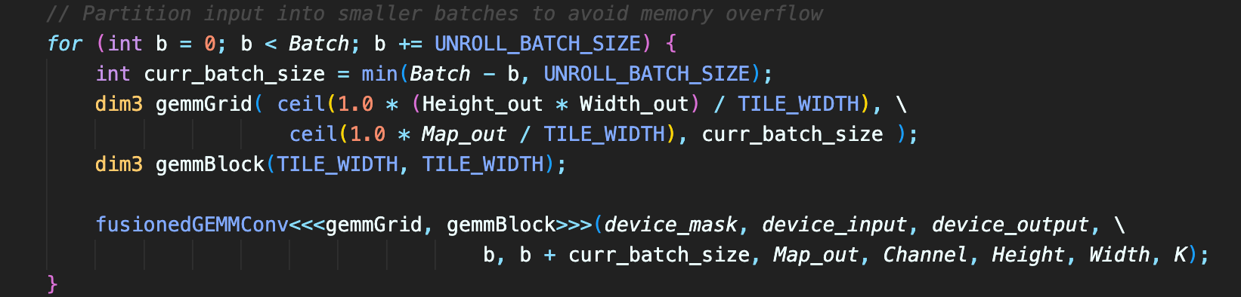

The kernel first loads data from the mask to shared memory, then loads data from input to shared memory according to computed unrolled matrix coordinates. Finally, the kernel does matrix multiplication within the tile. Core kernel code:

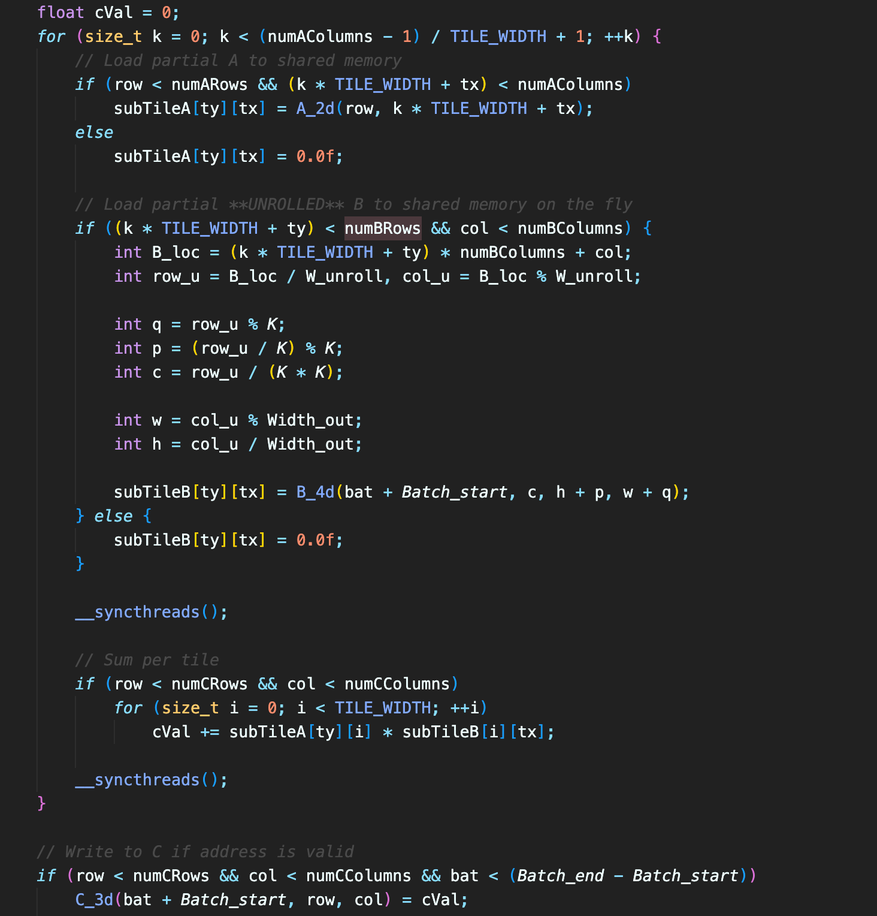



* 1. Did the performance match your expectation? Show your analysis results using profiling tools.

|  |  |  |  |  |
| --- | --- | --- | --- | --- |
| Batch Size | Op Time 1 | Op Time 2 | Total Execution Time | Accuracy |
| 100 | *0.500297 ms* | *0.336731 ms* | *0m3.995s* | *0.86* |
| 1000 | *4.11084 ms* | *3.16995 ms* | *0m38.062s* | *0.886* |
| 10000 | *40.4818 ms* | *31.4018 ms* | *6m3.557s* | *0.8714* |

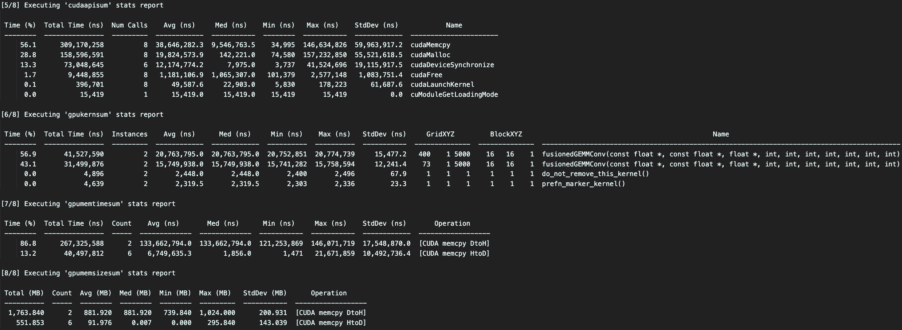

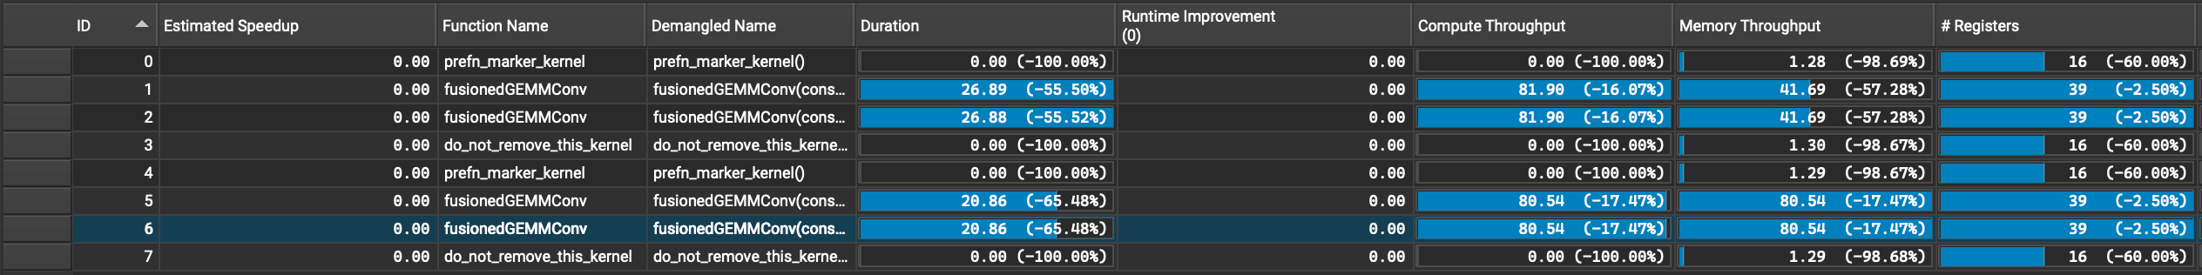

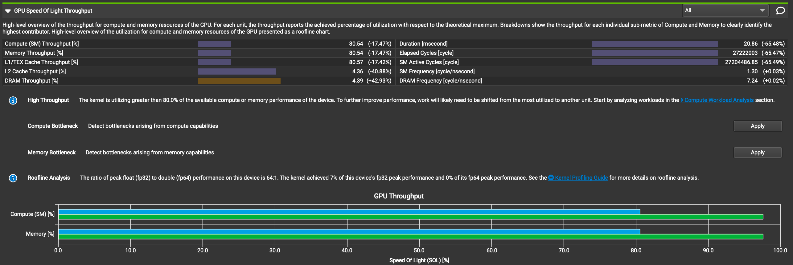



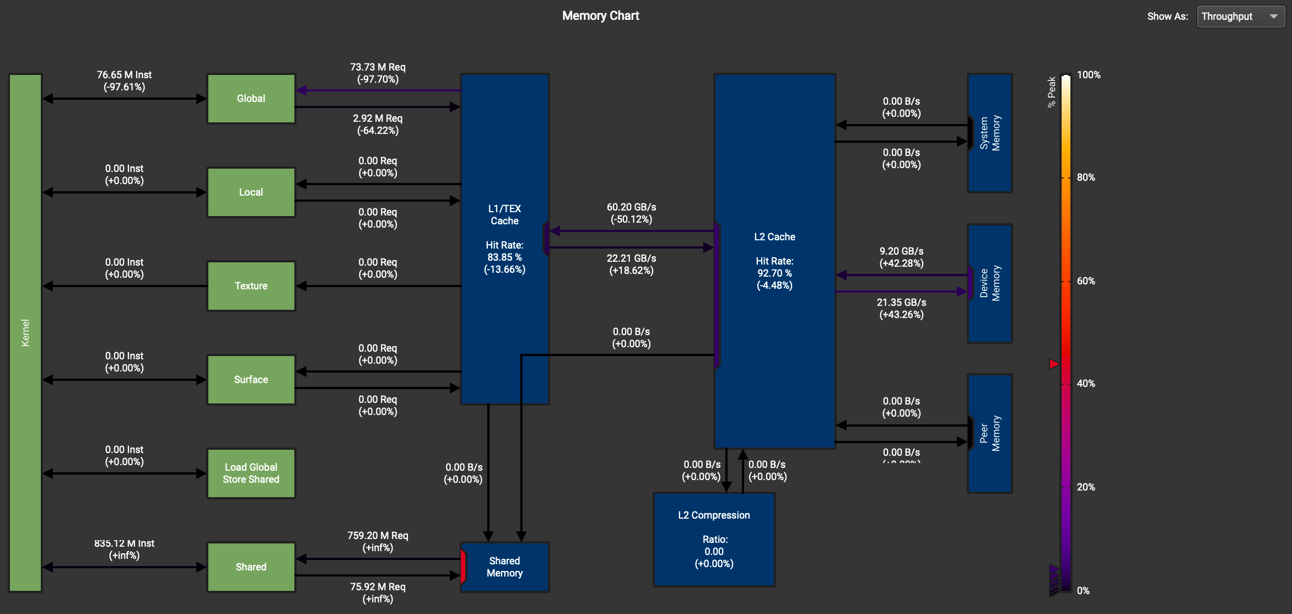

Not exactly. Memory workload analysis table still showed an increase in memory throughput (less than the increase in OP2), despite the expected decrease in the throughput of global memory and an increase in the throughput of shared memory. Total execution time decreased as expected, due to improved GEMM performance. OP Time increased compared to the baseline as expected as well.

* 1. Does this optimization synergize with any other optimizations? How and why?

Yes, it can synergize with optimizations like OP4 and OP6. we can store the weight matrix in constant memory since the mask is frequently used and won’t be changed in a layer; For OP6, we can try different tile widths, block sizes, etc. to find the optimal parameters. OP4 and OP6 can act as add-ons to OP3 to further improve performance.

* 1. List your references used while implementing this technique. (you must mention textbook pages at the minimum)

Hwu, W. M. W., Kirk, D. B., & Hajj, I. E. (2022). Programming Massively Parallel Processors: A Hands-on Approach, Fourth Edition, pages 107-112, 376-385.

1. **[Extra Point] Optimization Number 4: Weight matrix (Kernel) in constant memory**
   1. How does this optimization work in theory? Expected behavior?

The mask won’t be changed during convolution so it’s a good candidate for the constant memory, which is way faster than the global memory.

The throughput of global memory, total execution time, and OP Time should all decrease.

* 1. How did you implement your code? Explain thoroughly and show code snippets.

The code is very similar to the baseline except now the mask is copied to constant memory through cudaMemcpyToSymbol.





The kernel now loads the mask from constant memory. Nothing else needs to be changed for this part.



* 1. Did the performance match your expectation? Show your analysis results using profiling tools.

|  |  |  |  |  |
| --- | --- | --- | --- | --- |
| Batch Size | Op Time 1 | Op Time 2 | Total Execution Time | Accuracy |
| 100 | *0.120636 ms* | *0.39472 ms* | *0m5.014s* | *0.86* |
| 1000 | *0.906578 ms* | *3.76148 ms* | *0m36.781s* | *0.886* |
| 10000 | *8.7681 ms* | *37.4801 ms* | *6m8.585s* | *0.8714* |

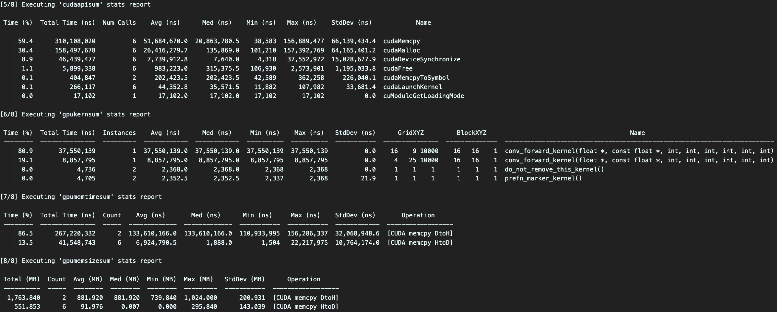



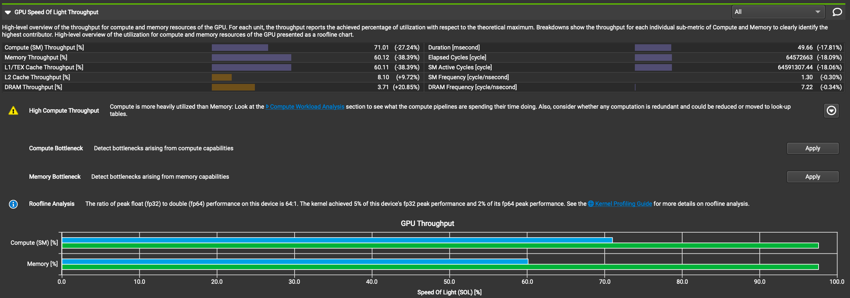



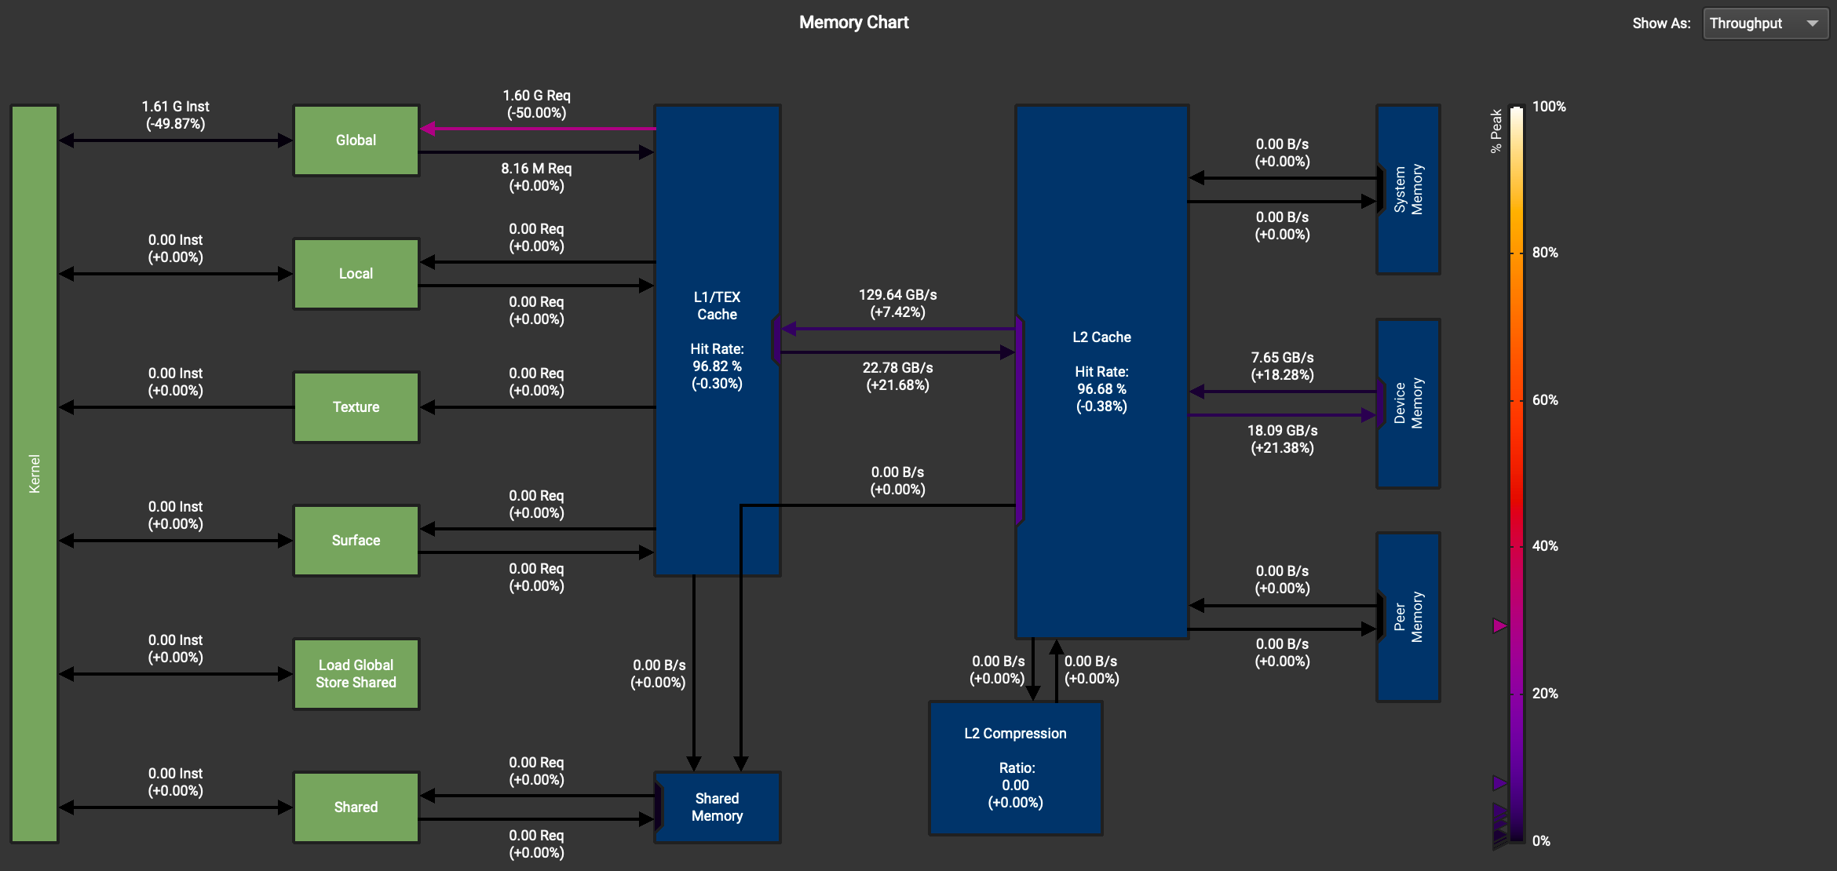

Yes. Memory workload analysis chart showed a decrease in global memory throughput. Total execution time decreased as expected, due to fewer cycles required to load data from constant memory. OP Time decreased compared to the baseline as expected as well.

* 1. Does this optimization synergize with any other optimizations? How and why?

Yes, it can synergize with optimizations like OP1 and OP3. How and why has been explained in OP1 and OP3.

* 1. List your references used while implementing this technique. (you must mention textbook pages at the minimum)

Hwu, W. M. W., Kirk, D. B., & Hajj, I. E. (2022). Programming Massively Parallel Processors: A Hands-on Approach, Fourth Edition, pages 94-103.

1. **Optimization Number 10: Fixed point (FP16) arithmetic implementation**
   1. How does this optimization work in theory? Expected behavior?

Using FP16 increases performance because of the reduced data sizes, memory transfers, and improved float-point arithmetic performance. Accuracy shouldn’t change much since deep learning results aren’t heavily dependent on data precision.

Throughput of global memory, total execution time, and OP Time should all decrease.

* 1. How did you implement your code? Explain thoroughly and show code snippets.

I chose to do typecasting on the host for lower OP Time. Two values from the same channel and coordinate, but from consecutive batches, are combined and stored in a single __half2 value. Casting host code:

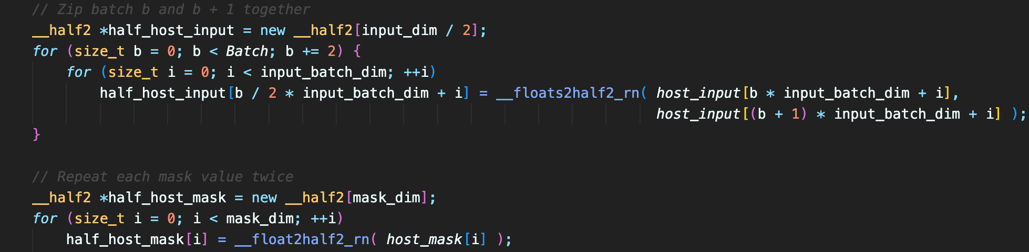

Then call the kernel with explicitly casted __half2 parameter:



The kernel does convolution with CUDA Math APIs:

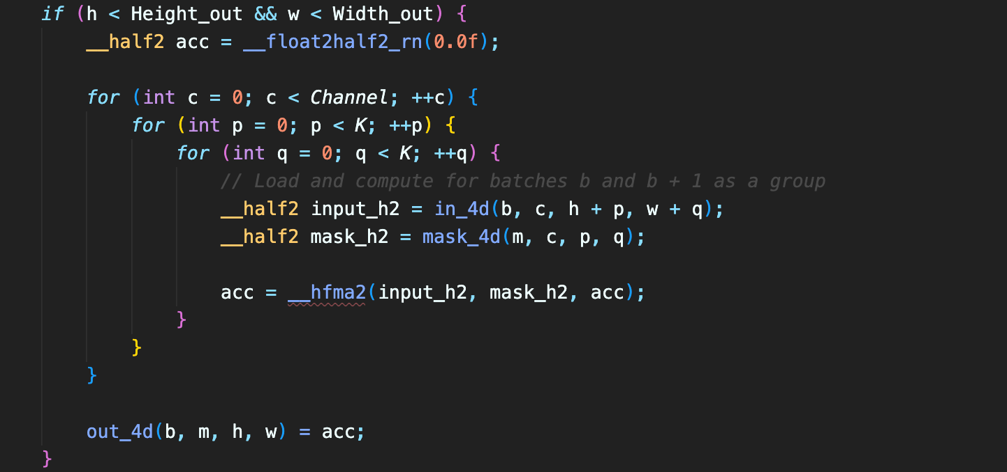

Finally, the host unzips the __half2 array and stores float values back to the output:

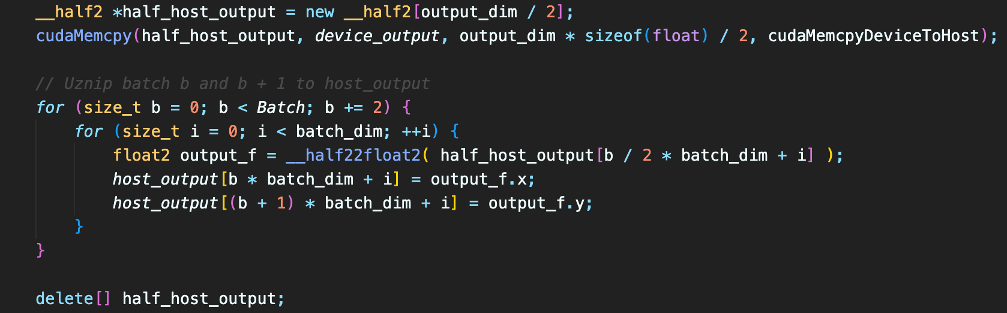

* 1. Did the performance match your expectation? Show your analysis results using profiling tools.

|  |  |  |  |  |
| --- | --- | --- | --- | --- |
| Batch Size | Op Time 1 | Op Time 2 | Total Execution Time | Accuracy |
| 100 | *0.141886 ms* | *0.249757 ms* | *0m4.510s* | *0.86* |
| 1000 | *0.66223 ms* | *2.29257 ms* | *0m39.716s* | *0.887* |
| 10000 | *5.80829 ms* | *22.5851 ms* | *6m28.956s* | *0.8716* |

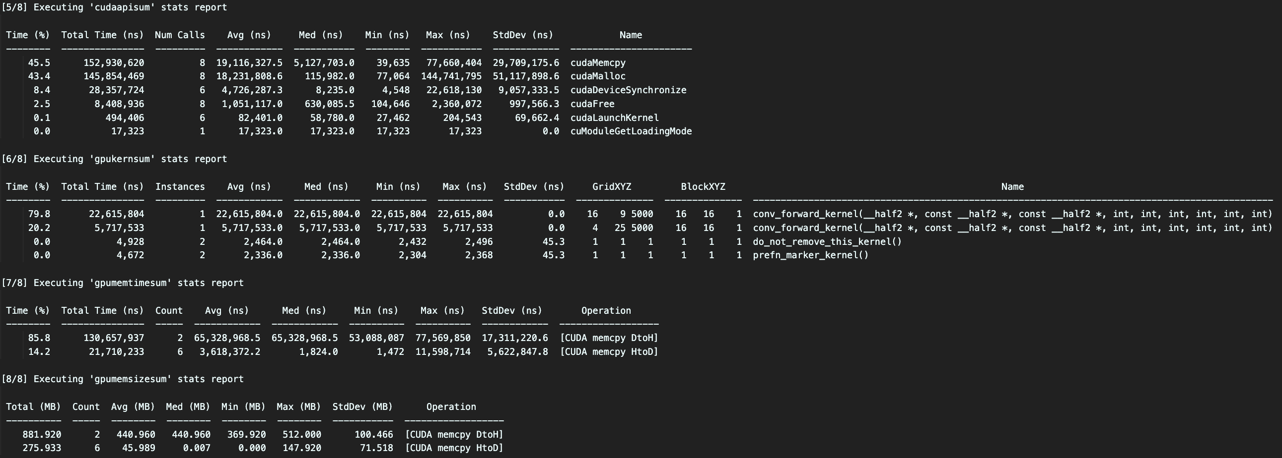



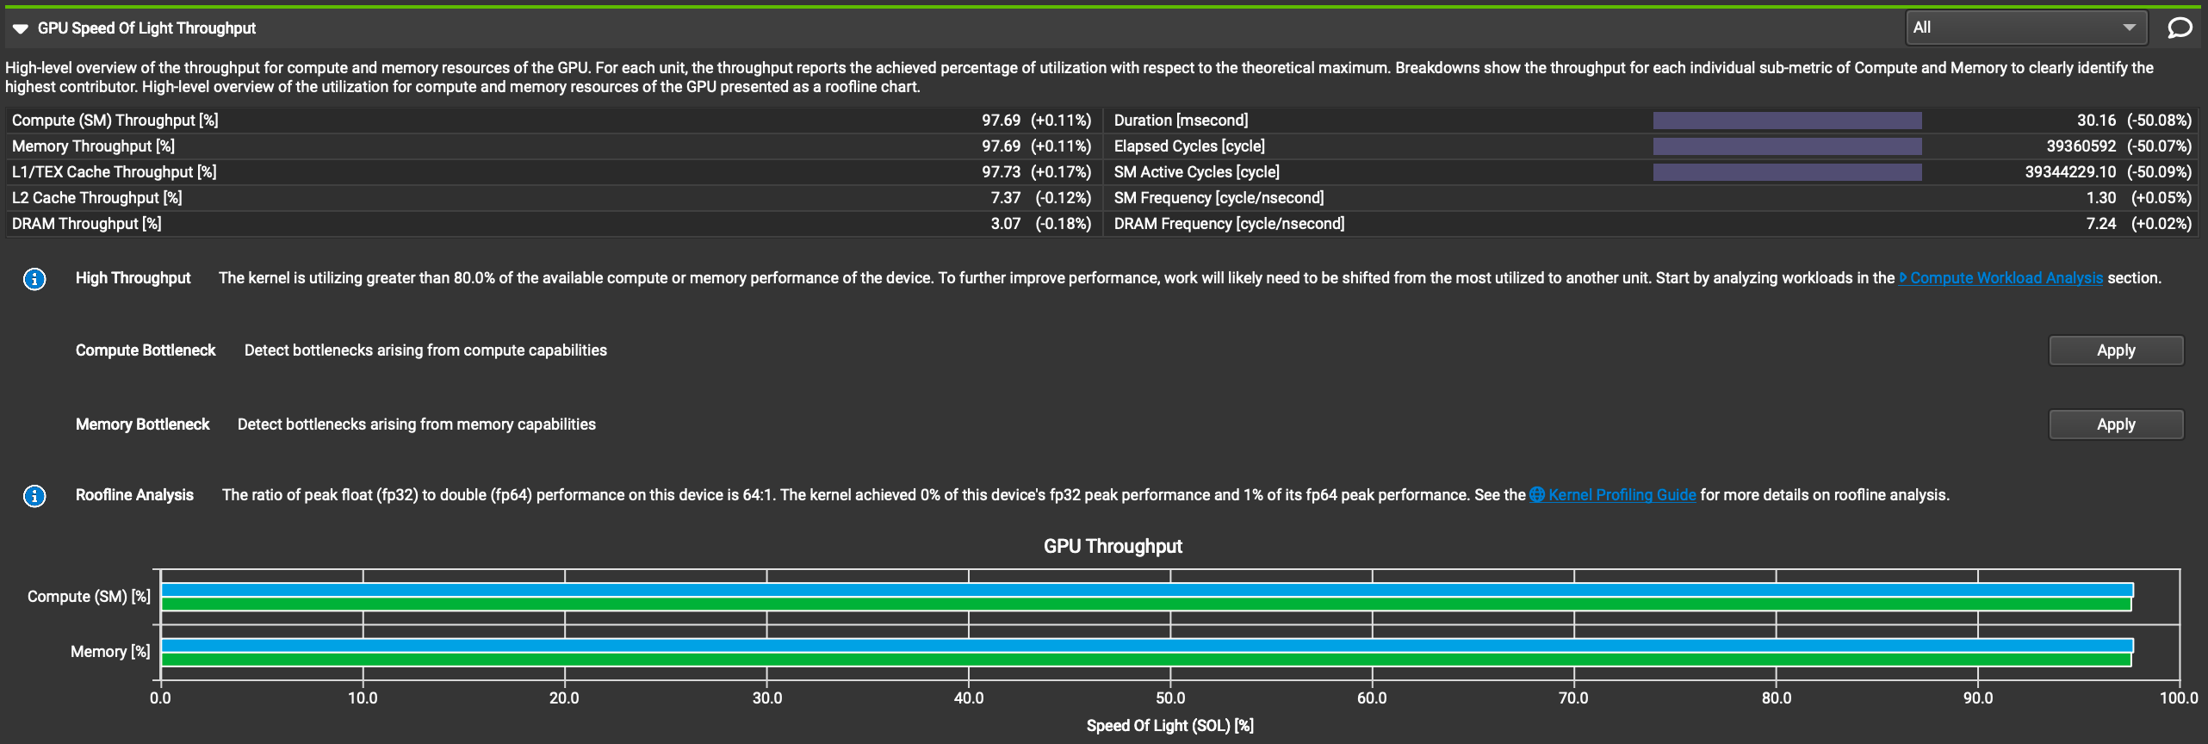



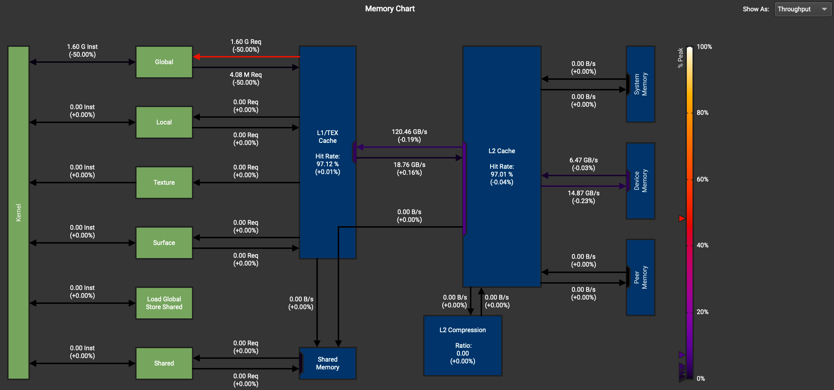

Not exactly. Memory workload analysis chart showed about a 50% decrease in global memory transfer, which is expected because of the halved size of the data. OP Time decreased significantly compared to the baseline as expected as well. However, the total execution time increased. That’s because the host requires much more time than the device to do typecasting.

* 1. Does this optimization synergize with any other optimizations? How and why?

Yes, it can synergize with any other optimization. This optimization only changes data types and doesn’t change other computation logics. Synergizing can be achieved by typecasting before the kernel invocation and then using CUDA Math APIs to replace the original computation operators.

* 1. List your references used while implementing this technique. (you must mention textbook pages at the minimum)

Milestone 3 slides, pages 29-34.

CUDA MATH API, 1.2.6. Half Precision Conversion and Data Movement, <https://docs.nvidia.com/cuda/cuda-math-api/group__CUDA__MATH____HALF__MISC.html>

CUDA MATH API, 1.2.3. Half2 Arithmetic Functions, https://docs.nvidia.com/cuda/cuda-math-api/group__CUDA__MATH____HALF2__ARITHMETIC.html#group__CUDA__MATH____HALF2__ARITHMETIC